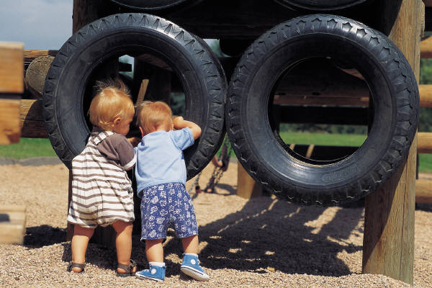




Wisconsin Model Early Learning Standards Training

January 17 & February 7, 2014
Registration: 8:00 - 8:30 a.m. Workshop: 8:30 a.m. - 4:00 p.m.
(Participants need to attend both days.)
Viterbo credit pending

This training will provide participants with an opportunity to explore the WMELS standards so that they will be able to use them to build a foundation for high quality care and education for ALL children from birth to the beginning of first grade.

Participants will learn how to apply the WMELS Performance Standards to:
- determine what children should know and be able to do,
- plan learning experiences,
- provide supportive environments, and
- collect data to ensure that all children are learning and making progress.

Outcomes of the WMELS training include:
- Understand the WMELS domains, sub-domains, developmental expectations/performance standards/program standards, developmental continuum, and guiding principles.
- Use the process of screening, observation, and assessment to identify current status of a focus child.
- Use the teaching cycle (Planning and Curriculum goals; Implementation; Assessment) to intentionally plan for children to meet developmental expectations.
- Use assessment tools to organize information to determine goals and plan activities.
- Practice planning for large group, small group and individualized instruction as well as embedding goals within daily routines and learning centers.
- Reflect on current teaching practices using the teaching cycle.
- Understand the importance of using the WMELS as a guide, along with Common Core for 5K, to determine local benchmarks/learning targets that will inform decision-making regarding curriculum and assessment.

Approved Trainers: Stephanie Lulich, CESA #12, Sue Erickson, CESA #12 and Northwest Connection Family Resource Center

Audience: Administrators, Early Head Start and Head Start, Group and Family Child Care, B-3, ECSE, 4‐5K, Community Site Partners (4K,Head Start, Child Care), and others who would find this content useful in their work or life
Location:
CESA #12 Conference Center, 618 Beaser Ave., Ashland, WI 54806
Cost: $45 per participant (includes materials, break and lunch)

The WMELS Training addresses most areas of the Wisconsin Core Competencies, Registry Core Knowledge/Competency Areas, the ten DPI Teacher Standards, and INTASC Standards.

Registration Deadline: January 10, 2014 To Register: Go to www.myquickreg.com

QUESTIONS? Call Stephanie Lulich, 715-682-2363, ext. 141 (stephaniel@cesa12.org) or Sue Erickson, 715-682-2363, ext. 135 (suee@cesa12.org)
This workshop is co-sponsored by the CESA 12 Early Childhood Discretionary Grant #14-74-9912 -PIDEA60 CFDA#84.173 & Northwest Connection Family Resource Center.

